Error: Reference source not found
–
Author: Sanjay G S

1. Abstract 3
2. Purpose 3
3. Scope 3

4. System Features And Requirement …………………………………………………………………….. 4
4.1 Functional Requirements….………………………………………………………………………….4
4.2 Non Functional Requirements……………………………………………………………………….5
5. High Level Design ………………………………………………………………………………………………7

5.1 System Architecture Overview …………………………………………………………………….8

5.2 Key Components and Their Roles …………………………………………………………………8

5.3 Module Interaction Flow …………………………………………………………………………….9
5.4 Technology Stack ………………………………………………………………………………………9
5.5 Design Considerations 9……………………………………………………………………………..9
5.6 Deployment Strategy ……………………………………………………………………………….10
6. Low Level design……………………………………………………………………………………………….10

6.1 Component-Level Breakdown ………………………………………………………………….10
6.2 API Endpoints ………………………………………………………………………………………..11

6.3 Authentication and Authorization Logic …………………………………………………….11
6.4 Error handling ………………………………………………………………………………………..12
6.5 Secuirty Consideration ……………………………………………………………………………12
6.6 UI Flow and Navigation …………………………………………………………………………..12
7 Diagrams ………………………………………………………………………………………………………….12
7.1 Flow Chart ……………………………………………………………………………………………..13
7.2 ER – Diagram …………………………………………………………………………………………14
7.3 Use case diagram ……………………………………………………………………………………15
7.4 Class Diagram ………………………………………………………………………………………..16
7.5 Sequence Diagram ………………………………………………………………………………….17

1.Abstract:
This Software Requirements Specification (SRS) document details the design and functionality of an e-commerce application developed using React. The application aims to provide users with a comprehensive online shopping experience by allowing them to browse products, manage shopping carts, and complete purchases efficiently.
Key features of the application include user authentication, enabling account creation and login, which allows users to save their shopping preferences and order history. The shopping cart functionality facilitates the addition and removal of products, along with real-time price updates based on selected items. The application also integrates a streamlined checkout process, where users can enter shipping details and finalize their orders.
For administrators, the application includes a dedicated dashboard that provides tools for managing user accounts and product listings. Admins can view user details, monitor order histories, and modify product information, ensuring a smooth operational flow.
The application utilizes a JSON Server to simulate a backend, ensuring that data management is efficient and secure. The design prioritizes a user-friendly interface and responsiveness across devices, enhancing user engagement and satisfaction.

2.Purpose
The purpose of this document is to define the software requirements for the development of an e-commerce application using React. This system aims to provide a seamless and interactive online shopping experience for users, with features such as browsing products, managing a shopping cart, placing orders, and tracking order history. Additionally, the application includes an admin portal to manage users, products, and monitor order activity.
This document is intended for:
- Developers to understand functional and non-functional requirements.
- Project managers to track development milestones.
- Testers to design test cases and verify the system’s behaviour.
- Stakeholders to validate whether the system meets business goals.

3. Scope
This e-commerce application simulates a fully functional online shopping platform built with React and a JSON Server backend. The key features of the system include:
- User authentication and profile management for both customers and admins.
- Product management with options to browse, filter, and sort products.
- Shopping cart functionality that allows users to add, remove, and update product quantities with real-time total price calculations.
- Order placement and shipping process, including collection of delivery details and payment type.
- Order history management, allowing users to view past orders, delivery status, and cancel orders within 24 hours.
- Admin dashboard for managing user accounts, monitoring activity logs, and controlling product listings.
- Persistent data handling using JSON Server to simulate database operations for users, products, carts, and orders.
4. System Features And Requirement
4.1.FUNCTIONAL REQUIREMENT

1. User Authentication & Authorization
- Users should be able to register by providing essential details like name, email, password, and phone number.
- Users should be able to log in using their email and password.
- The system should allow admin login with predefined credentials for managing the platform.
- A logout feature should be available for both users and admins.
- The system should restrict access to certain pages (Cart, Shipping, Order History) for unauthenticated users.

2. Product Management
- The system should allow admins to add, edit, and delete products.
- Each product entry must contain name, price, brand, description, gender, rating, color, and images.
- Users should be able to view a product catalog and search for products by attributes (e.g., brand, rating).
- Clicking on a product should take users to a detailed product page.
- Users should be able to browse products without login.

3. Shopping Cart Management
- Users should be able to add products to the cart.
- Users should be able to update the quantity of each product in the cart.
- Products in the cart should display a subtotal amount, and the total should update dynamically.
- Users can remove products from the cart.
- The system should store the user’s cart data for future sessions.

4. Order and Shipping Management
- Users should be able to enter delivery information (address, phone number, and email) during checkout.
- A "Place Order" button should confirm the order and provide a success message.
- The order should include a delivery date, which is two days from the current date.
- Users should be able to view their order summary on the Order History page.
- Orders should be cancellable within 24 hours.
- The system should display the payment method during order placement.

5. Order History Management
- Users should have access to their order history with detailed order information (product details, order date, status).
- The system should show the delivery status (e.g., delivered, cancelled).
- Users should be able to cancel orders within the allowable time frame.

6. Admin Portal and Dashboard
- The admin dashboard should allow viewing all users and products.
- Admins should be able to view, edit, or delete user information.
- The product management interface should provide options to add new products or modify existing ones.
- Admins can ban or deactivate users if necessary.

7. Notifications & Alerts
- Users should receive an order confirmation message after placing an order.
- Admins should receive notifications for user activities, such as new orders or cancellations.

8. Navigation & Usability
- Users should be able to navigate between the home, product, cart, and checkout pages easily.
- The navbar should provide quick access to login, sign up, and cart options.
- The system should provide error handling for invalid pages or actions, with appropriate messages (e.g., "Invalid Credentials" on login failure).

9. Data Storage & Retrieval
- The cart, user data, and order history should be stored in the backend database.
- Admin modifications (e.g., product updates) should be persistently saved in the database.
4.2.NON FUNCTIONAL REQUIREMENTS:

1. Performance Requirements
- The system should respond to user actions (e.g., login, add to cart) within 2 seconds.
- Page loads, including product catalog and order history, should complete in less than 3 seconds.
- The backend (JSON Server) should handle up to 50 concurrent users efficiently without downtime.

2. Scalability Requirements
- The application should be able to scale horizontally if migrated to a more complex backend in the future (e.g., Node.js or MongoDB).
- The system should allow the addition of new products or user accounts without performance degradation.

3. Usability Requirements
- The system should provide a simple and intuitive UI, ensuring users can complete key actions (e.g., login, checkout) within 2-3 clicks.
- The navigation bar should always remain visible to allow easy access to login, cart, and product pages.
- Form elements (e.g., sign-up and shipping forms) should be mobile-friendly with proper field validation and clear error messages.

4. Availability Requirements
- The application should be available 24/7 without interruption.
- In case of backend failure (JSON Server), the system should notify users with a friendly error message (e.g., "Service Unavailable").

5. Security Requirements
- User passwords should be hashed before being stored (if migrated to a real backend in the future).
- Only authenticated users should be able to access sensitive pages like the cart, shipping, and order history.
- Admin credentials should be validated securely to prevent unauthorized access to the admin dashboard.

6. Maintainability Requirements
- The codebase should follow a modular structure (e.g., separate components for Login, Cart, Products) to allow easier updates and maintenance.
- Documentation of key components should be provided to enable future developers to easily modify the system.
- The system should be easy to extend, allowing the addition of new features (e.g., payment gateway integration) with minimal code changes.

7. Portability Requirements
- The system should work across all major browsers (Chrome, Firefox, Edge, Safari).
- The application should be compatible with both desktop and mobile platforms.

5.HIGH LEVEL DESIGN:

5.1. System Architecture Overview
The system follows a 3-tier architecture with:
- Frontend: React application to handle user interaction and rendering UI.
- Backend: JSON Server (simulated backend) to store and manage data.
- Database: JSON file serving as a mock database.

5.2. Key Components and Their Roles

5.2.1.Frontend Components (React)
- NavBar Component
  - Displays navigation options like Login, Signup, Products, Cart.
  - Conditional rendering based on user authentication state.
- Products Component
  - Fetches and displays a list of products from the backend.
  - Allows users to add items to the cart.
- Cart Component
  - Displays all products added to the cart.
  - Provides the total price and quantity control.
  - Has a 'Proceed to Buy' button navigating to the Shipping page.
- Shipping Component
  - Collects user shipping details and stores them along with the order.
  - Default user email is pre-filled from the authentication context.
- OrderHistory Component
  - Displays all orders placed by the user.
  - Provides options to cancel orders within 24 hours.
- Login and Signup Components
  - Handles user authentication and registration using forms.
  - Redirects to the relevant pages upon successful login or signup.
- Admin Components
  - AdminLogin: Authenticates the admin based on predefined credentials.
  - AdminDashboard: Provides access to user management and product management pages.
  - UserDetails: Displays user profiles and activity logs.
  - ProductManage: Allows admins to add, update, or delete products.

5.2.2.Backend (JSON Server)
- Routes and Endpoints:
  - /users: Manages user authentication and data.
  - /products: Stores product details.
  - /cart: Holds cart data for individual users.
  - /orders: Manages order data with delivery and cancellation statuses.

5.3. Module Interaction Flow

Login Flow
- User enters credentials and submits the login form.
- React frontend validates the user by sending a request to the /users endpoint.
- Upon successful login, the user is redirected to the Products page, and their session is managed using AuthContext.

Add to Cart and Checkout Flow
- The user selects products and clicks Add to Cart.
- The cart items are displayed on the Cart page, with quantity controls.
- On clicking Proceed to Buy, the user is navigated to the Shipping page.
- After entering shipping details, the order is stored under /orders.

Order History and Cancellation Flow
- Users can view all their orders in the OrderHistory component.
- Orders can be canceled within 24 hours by sending a request to /orders.
- Orders are marked as Delivered 2 days after placement.

Admin Dashboard Interaction
- Admin logs in using the AdminLogin page.
- On successful authentication, they are redirected to the AdminDashboard.
- Admins can manage users and products through the UserDetails and ProductManage components.

5.4. Technology Stack
- Frontend: React.js with React Router for navigation.
- State Management: React Context API (AuthContext).
- Backend: JSON Server (for simulation).
- Database: JSON file (mock data).
- Styling: CSS (with Bootstrap for improved UI).

5.5. Design Considerations
- Security
  - Authenticated routes for user and admin components.
  - Admin credentials verified securely using a hardcoded admin JSON.
- Scalability
  - Can be easily migrated to a more robust backend such as Node.js.
  - Products and users stored in a structured JSON format for easy expansion.
- Maintainability
  - Modular components (e.g., separate Login, Cart, and Product pages).
  - Simple state management using Context API for easy code management.

5.6. Deployment Strategy
- Development: Run React frontend with npm start and JSON Server with json-server --watch db.json.
- Production: Can be deployed to Netlify or Vercel for the frontend and Heroku for the backend JSON Server.
6.LOW LEVEL DESIGN:

6.1. Component-Level Breakdown
- NavBar Component
  - Displays navigation links dynamically based on user authentication state.
  - Conditional Rendering: If logged in, it shows Cart, Order History, and Logout. If not, it shows Login and Signup.
- Products Component
- Fetches products from the /products endpoint.
- Renders a list of products with Add to Cart buttons.
- Functionality: When a product is added, it sends a request to update the user’s cart.
API Interaction:
- GET /products: Retrieve all products.
- POST /cart: Add a product to the cart.
- Cart Component
- Retrieves the cart items based on the logged-in user’s email.
- Allows the user to update product quantities or remove items from the cart.
API Interaction:
- GET /cart?userEmail=<email>: Retrieve user's cart.
- DELETE /cart/:id: Remove product from cart.
- Shipping Component
- Collects user’s delivery address and payment details.
- On Submission: Sends an order to /orders with user email, cart items, and shipping details.

API Interaction:
- POST /orders: Place a new order.
- OrderHistory Component
- Fetches and displays all orders placed by the logged-in user.
- Allows order cancellation if it’s within 24 hours.
API Interaction:
- GET /orders?userEmail=<email>: Fetch user’s orders.
- PATCH /orders/:id: Update or cancel order status.
Admin Components
- AdminLogin: Verifies credentials and logs in the admin..
- AdminDashboard: Displays management options.
- UserDetails: Shows detailed information about each user.
- ProductManage: Allows adding, editing, and deleting products.

6.2. API Endpoints
- Users
  - GET /users: Retrieve all users.
  - POST /users: Add a new user (signup).
- Products
  - GET /products: Retrieve all products.
  - POST /products: Add a new product (admin).
  - DELETE /products/:id: Delete a product (admin).
- Cart
  - GET /cart?userEmail=<email>: Retrieve user’s cart.
  - POST /cart: Add product to cart.
  - DELETE /cart/:id: Remove product from cart.
- Orders
  - GET /orders?userEmail=<email>: Retrieve user’s orders.
  - POST /orders: Place an order.
  - PATCH /orders/:id: Update order status.

6.3. Authentication and Authorization Logic
- User Authentication:
  - On login, user details are verified against the /users endpoint.
  - User session is managed using React Context (AuthContext).
- Admin Authentication:
  - Admin credentials are verified through a dedicated endpoint /admin-login.
  - Admin-only routes are protected through conditional rendering.

6.4. Error Handling
- Frontend: Display alerts for failed operations (e.g., incorrect login).
- Backend: Return appropriate HTTP status codes (e.g., 404 for not found, 401 for unauthorized).

6.5. Security Considerations
- Password Hashing: Store hashed passwords (currently skipped for simplicity).
- Session Management: Use React Context for user authentication.
- Authorization: Prevent unauthorized access to admin routes.

6.6. UI Flow and Navigation
- Home Page → Products
- Products → Add to Cart → Cart Page
- Cart Page → Proceed to Buy → Shipping Page
- Shipping Page → Place Order → Order History
- Admin Login → Admin Dashboard → User/Product Management

7.Diagram:

7.1FlowChart
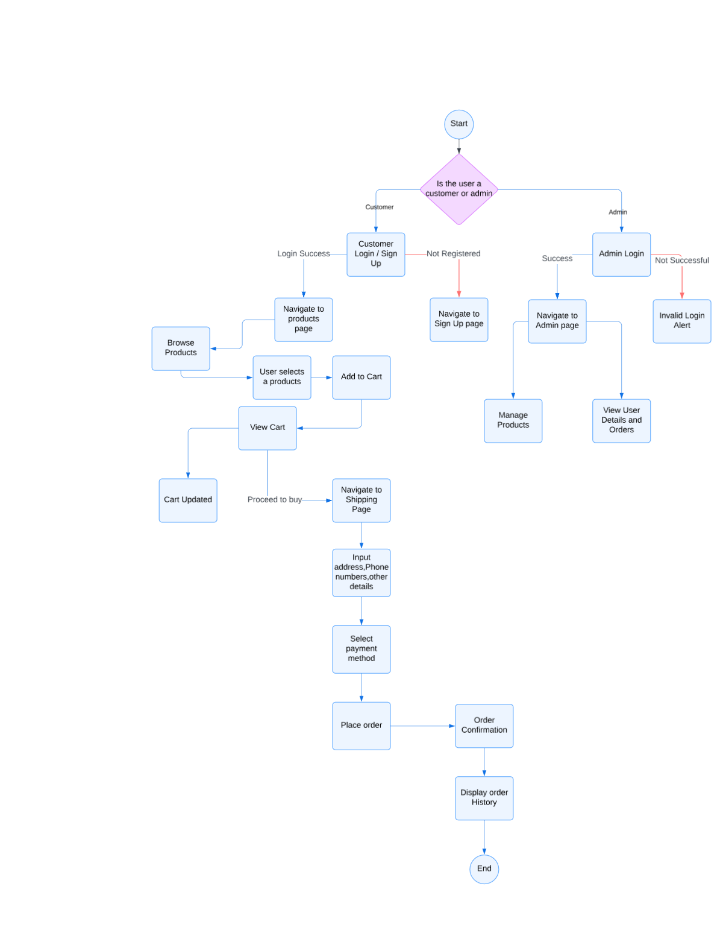
7.2ER-Diagram
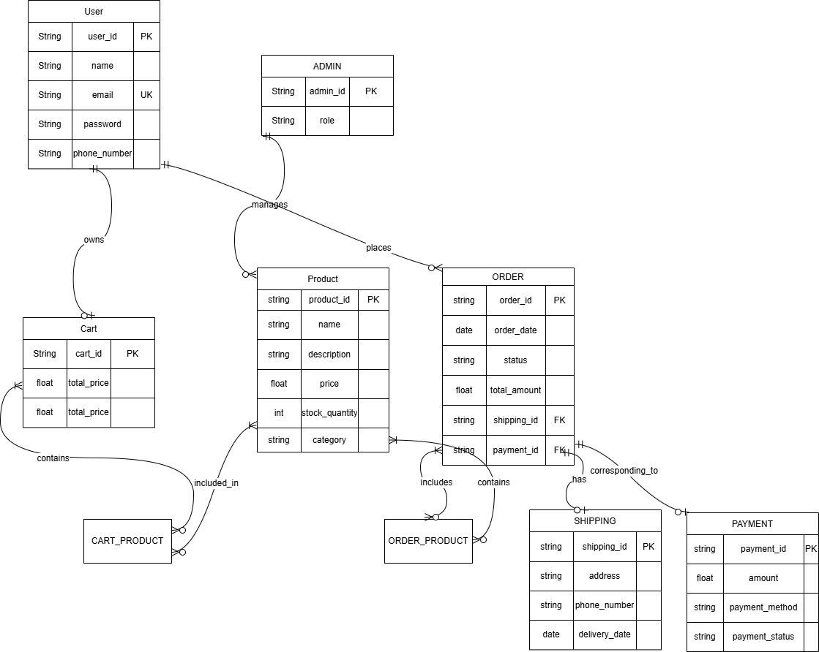

7.3Use-Case Diagram

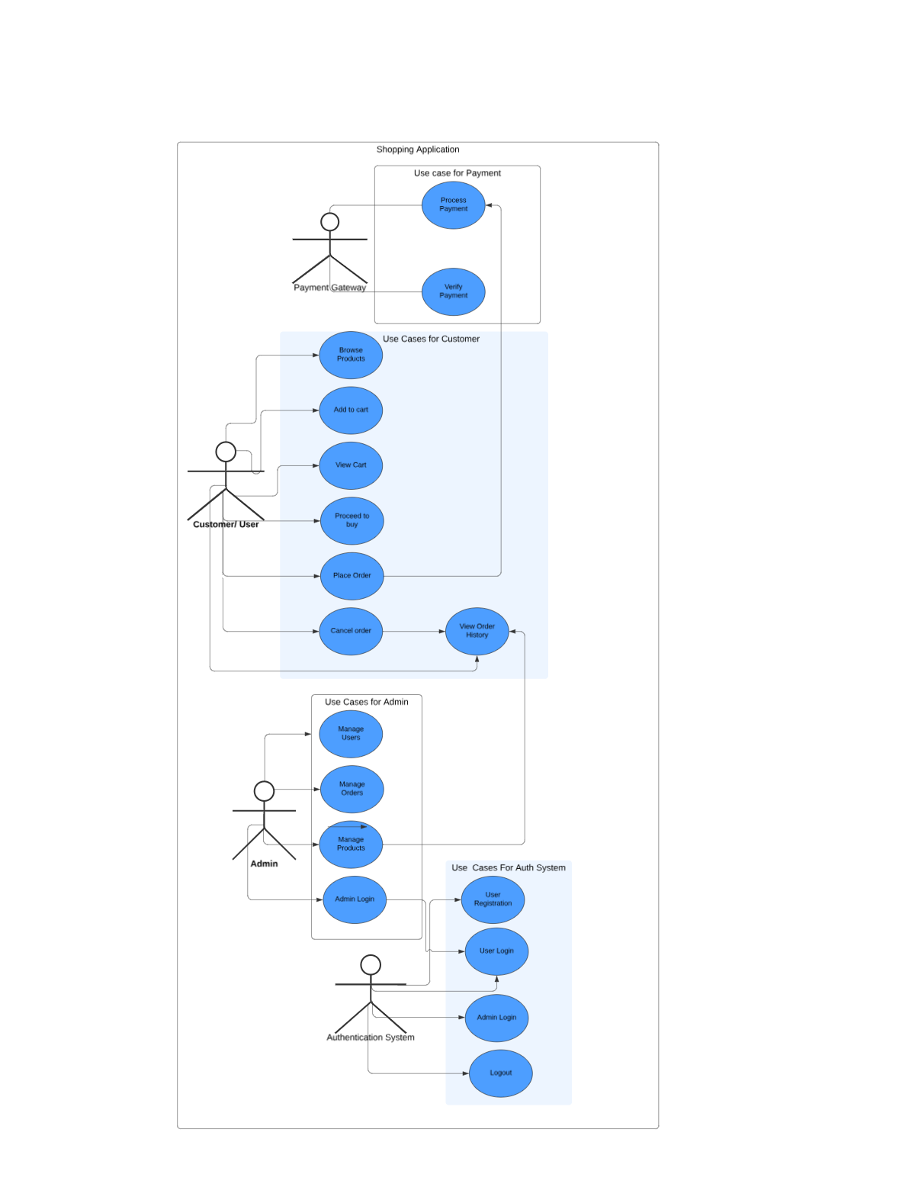
7.4Class Diagram
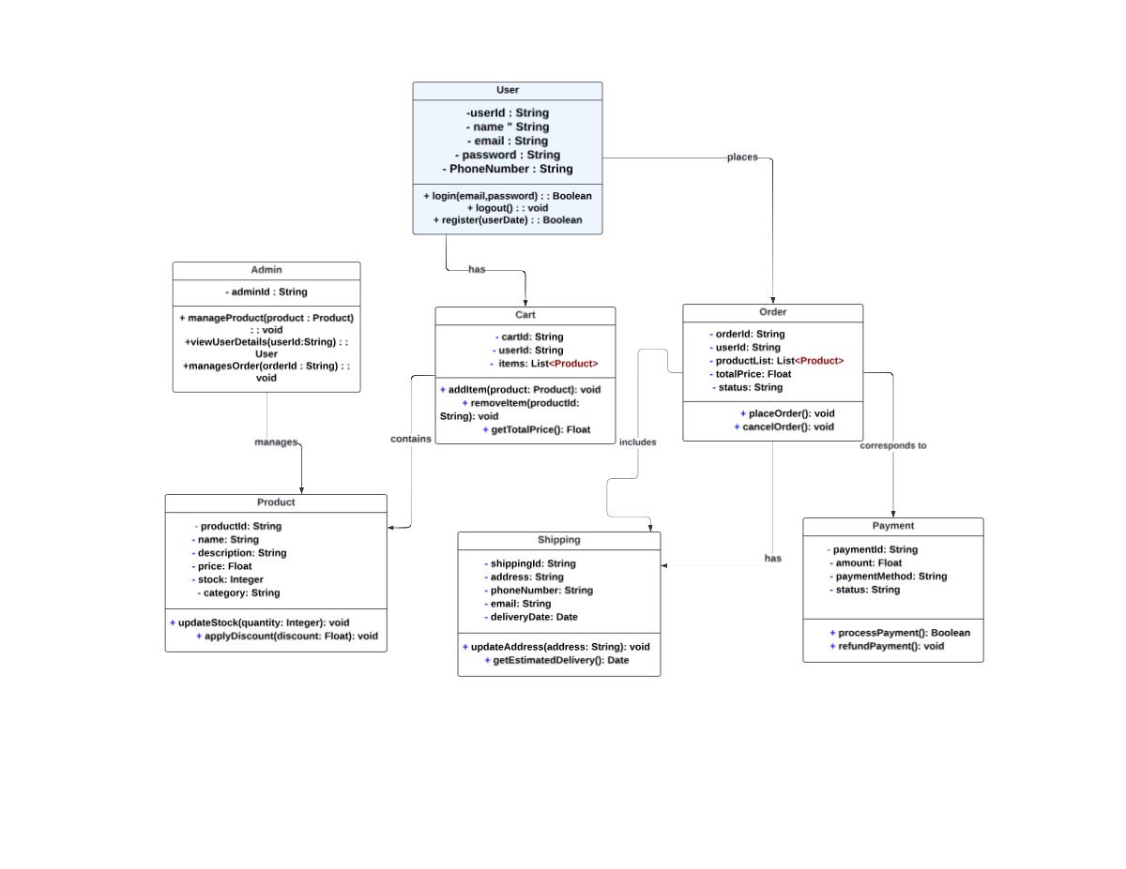

7.5.Sequence Diagram
